**Task No. 1:** In which year max no of fires were reported.

**Solution:**

import pandas as pd

dataset=pd.read_csv("amazon.csv",encoding="latin-1")

dataset

max_fires_year = dataset.groupby('year')['number'].sum().idxmax()

print(f"Year with the maximum number of fires reported: {max_fires_year}")

**Output:**

**Task No. 2:** Find average number of fires reported from highest to lowest with reference to state.

**Solution:**

import pandas as pd

dataframe =pd.read_csv("amazon.csv",encoding="latin-1")

dataframe

avg_fires_by_state = dataframe.groupby('state')['number'].mean().sort_values(ascending=False)

print("Average number of fires reported from highest to lowest with reference to state:")

print(avg_fires_by_state)

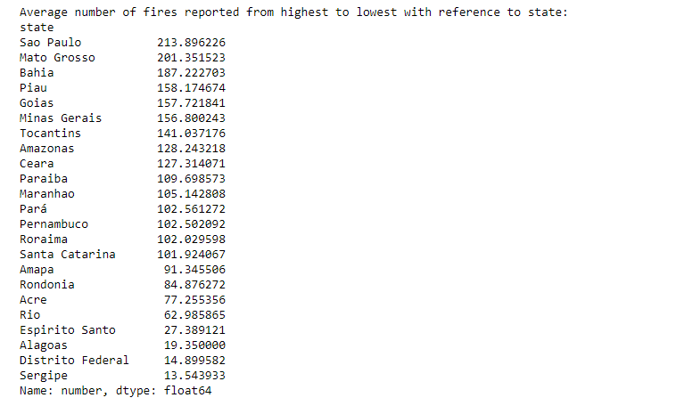**Output:**

**Task No. 3:** Find the state names where fire was reported in Dec.

**Solution:**

import pandas as pd

dataframe =pd.read_csv("amazon.csv",encoding="latin-1")

dataframe

december_states = dataframe[dataframe['month'] == 'Dezembro']['state'].unique()

print("States where fire was reported in December:")

print(december_states)

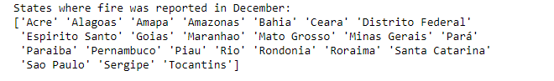**Output:**

**Task No. 4:** Report top 3 states where highest number of fires were reported.

**Solution:**

import pandas as pd

dataframe =pd.read_csv("amazon.csv",encoding="latin-1")

dataframe

top_3_states = dataframe.groupby('state')['number'].sum().sort_values(ascending=False).head(3)

print("Top 3 states with the highest number of fires reported:")

print(top_3_states)

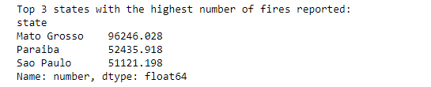**Output:**

**Task No. 5:** Report fires from Bahia, Acre, and Rio fetch data from 2010 to 2015 and number of fires greater than 0.

**Solution:**

import pandas as pd

dataframe =pd.read_csv("amazon.csv",encoding="latin-1")

dataframe

mask = (dataframe["state"] == "Rio") | (dataframe["state"] == "Acre") | (dataframe["state"] == "Bahia")

mask1=(dataframe["year"]> 2010) & (dataframe["year"] < 2016)

mask3=(dataframe["number"] >0)

dataframe[mask & mask1&mask3]

**Output:**

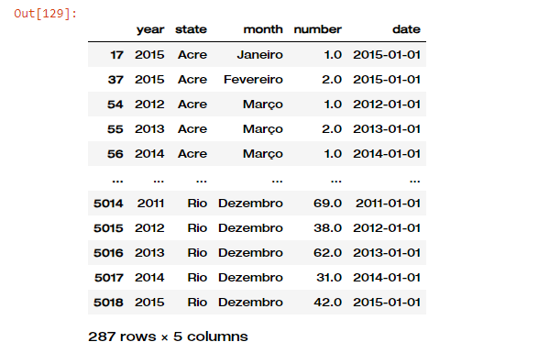

**Task No. 6:** Report year wise fires of the state with highest number of fires.

**Solution:**

import pandas as pd

dataframe =pd.read_csv("amazon.csv",encoding="latin-1")

dataframe

state_with_max_fires = dataframe.groupby('state')['number'].sum().idxmax()

year_wise_fires = dataframe[dataframe['state'] == state_with_max_fires].groupby('year')['number'].sum()

print(f"Year wise fires of the state with highest number of fires ({state_with_max_fires}):")

print(year_wise_fires)

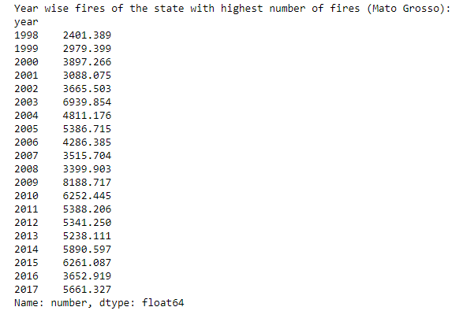**Output:**

**Task No. 7:** Find aggregate(sum, count, avg, max, min) of number of fires state wise.

**Solution:**

import pandas as pd

dataframe =pd.read_csv("amazon.csv",encoding="latin-1")

dataframe

state_wise_aggregate = dataframe.groupby('state')['number'].agg(['sum', 'count', 'mean', 'max', 'min'])

print("Aggregate (sum, count, mean, max, min) of number of fires state wise:")

print(state_wise_aggregate)

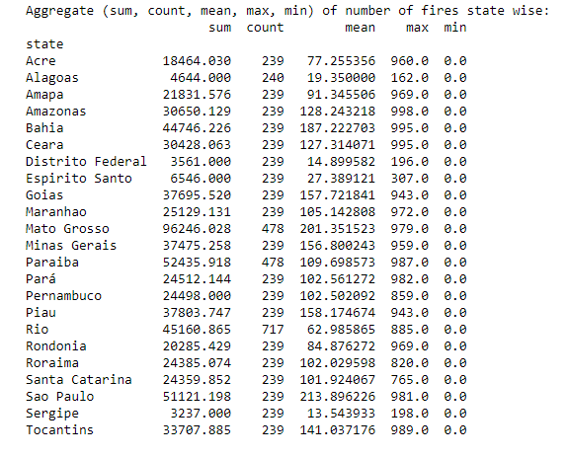**Output:**